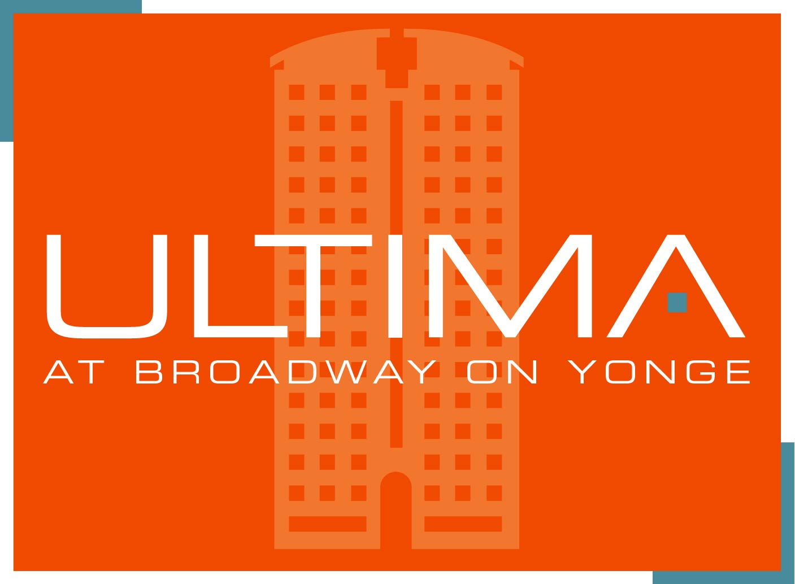
®
Property Management Inc. SUITE NO: ______________

TSCC 1741 4968 Yonge Street – South Tower
OWNER(S) / TENANT (S) REGISTRATION FORM
IN ORDER FOR US TO COMPLETE OUR OCCUPANCY RECORDS AS PER THE REQUIREMENTS OF THE Condominium Act, 1998, PLEASE FILL IN THE FOLLOWING & RETURN TO THE MANAGEMENT OFFICE PRIOR TO OCCUPANCY..
THANK YOU FOR YOUR CO-OPERATION

NAME OF REGISTERED UNIT OWNER(S)

(PLEASE PRINT CLEARLY)

DATE:

SUITE NO:

Owner First Name: ____________________________________ Owner Last Name: ______________________________

Owner First Name: ______________________________________ Owner Last Name: _____________________________

TELEPHONE: (H) (______) ___________________________ (B) (______) __________________________________

CELL PHONE: (______) ___________________________ EMAIL ADDRESS: _______________________________________

ADDRESS: ( for off-site Owners - correspondence to be directed to )
___________________________________________________________________________________________________________
Street & Number Suite No. City Province Postal Code

POSSESSION / LEASE START DATE: _____________________________ NUMBER OF BEDROOMS: _______________

TENANT(S) INFORMATION

TENANT LEASE START DATE: NO. OF BEDROOMS:

(Resident 1) SURNAME: ____________________________ (Resident 1) FIRST NAME: _____________________________________

SURNAME:____________________________ FIRST NAME: _______________________ Cell : _________________________

SURNAME:____________________________ FIRST NAME _______________________ Cell : _________________________

SURNAME:____________________________ FIRST NAME _______________________ Cell : _________________________

TELEPHONE (H): (______) _____________________________ (B): (______) ________________________________

EMAIL ADDRESS: _______________________________________

A. LOCKER NO: _____________LEVEL: ________ LOCKER NO: ______________LEVEL: ________
B. PARKING SPACE: _________LEVEL:______ LIC.NO:_________________ COLOUR / MAKE _____________________

PARKING SPACE: _________LEVEL:______ LIC.NO:__________________COLOUR / MAKE _____________________

C. KEYS IN YOUR POSSESSION:

BUILDING KEY # SUITE KEY # MAILBOX KEY # LOCKER KEY #_________

REMOTE /ACCESS CONTROL NO. :_____________________ ______________________ _____________________

LOCKER/BICYCLE ROOM: [ ] YES [ ] NO IF “YES”, HOW MANY: ____________

D. NAME OF PERSON REQUIRING HANDICAP ASSISTANCE: _________________________________________ N/A [ ]

E. TYPE & DESCRIPTION OF PET (S) _____________________________________________________________ N/A [ ]

_________________________________________________________________________________________________________
(PICTURE SUBMITTED TO MANAGEMENT- FOR OFFICE RECORD DATE: _____________________ )

F. ARE YOU ABSENT DURING ANY PART OF THE YEAR? [ ] NO [ ] YES - [ ] aware of Vacation Form

IF "YES", HOLIDAY ADDRESS__________________________________________________

__________________________________________________

PHONE NO: ________________________________________

G. EMERGENCY CONTACT: (FAMILY/CLOSE FRIEND)

NAME: ________________________________________ RELATIONSHIP: ____________________________________

TEL. NO.: (H) (______) ___________________________ (B) (_______) ________________________________________

NAME: ________________________________________ RELATIONSHIP: ____________________________________

TEL. NO.: (H) (______) ___________________________ (B) (_______) ________________________________________

_______________________________________________ ________________________________________
OWNER’S SIGNATURE DATE

[ ] I am aware of the Master Key system in the building and will not change the Initial Lock before consulting Management. I will only engage the Building’s Locksmith.

TENANTS ACKNOWLEDGEMENT

As Per Condominium Act 83.1 – LEASE OF UNITS, A Copy of Lease Agreement is provided Date: ________________

I hereby acknowledge and agree that I, the members of my household, and my guests, invitees, licenses, from time to time, will in using the unit rented by me, and the common elements, comply with the provisions of the “CONDOMINIUM ACT”, the Declaration, By-laws, Management Agreement, service agreements, and other agreements, and all rules and regulations of the Condominium Corporation (the Rules), during the term of the Tenancy Agreement and my tenancy, and will be subject to the same duties imposed by the Rules as if I were a unit owner, except for the payment of the common expenses, unless otherwise provided by the Condominium Act and any amendments thereto. A copy of the least

WITNESS WHEREOF, this _______day of__________________, Year_______ _in the City of _________________________

_________________________________________________ ________________________________________________
Witness Tenant

_________________________________________________ ________________________________________________
Witness Tenant

FOR OFFICE USE ONLY:
□ Parking Register Updated
□ Copy to Security
□ $5.00 Replacement Fee

VEHICLE REGISTRATION FORM

ULTIMA NORTH – 4978 Yonge Street ULTIMA SOUTH – 4968 Yonge Street

I, ___________________________________, of unit #_________, 49_____ Yonge St., hereby inform

Management of my vehicle information as described below. I certify that the information provided by

me is correct and agree to notify Management of any changes.

Spot | Parking Level | Make/Model | License Plate | Colour | Sticker Received  (Initial below)

Dated this __________ day of _______________________, 2011.

Print Owner Name: _______________________ Print Tenant Name: _______________________

Signature of Owner: _______________________ Signature of Tenant: _______________________

IMPORTANT:

PARKING STICKERS ARE TO BE PLACED ON THE DRIVER SIDE TOP CORNER OF THE WINDSHIELD AND MUST BE CLEARLY MARKED AND DISPLAYED AT ALL TIMES.

Toronto Standard Condominium Corporation

No. 1741
PET REGISTRATION FORM

The Board of Directors of T.S.C.C. No. 1741 have passed a rule that states that a maximum of two pets per residential unit are permitted, each pet to weigh a maximum of 10 kilograms (22 pounds). Pets must be leashed at all times and are not permitted to relieve themselves on the common elements. For further information please refer to the pet rule attached to your welcome package and available at the Management Office.

Suite No: T.S.C.C. No. 1741 (South)
(Please circle one)

Registered OWNER / RESIDENT’S information:
(Please circle one)

First Name: Last Name:
Numbers (Home): (Bus): (Cell):
E-mail:

Pet Registration:

NAME OF PET: Weight: Cat , Dog or Other

City License / Registration #. Colour:

NAME OF PET #2: Weight: Cat , Dog or Other

City License / Registration #. Colour:

Emergency Contact information

Name: Tel. #:

Signature: X Date:

SCHEDULE D

TORONTO STANDARD CONDOMINIUM CORPORATION No’s. 1741

PARCEL ACCEPTANCE WAIVER FORM

The undersigned resident(s), who is/are 18 years of age or older, of Toronto Standard Condominium Corporation No. __1741___ acknowledges that T.S.C.C. No. __1741____, Del Property Management Inc. or Concierge have no obligation whatsoever to accept, on behalf of any resident or tenant, delivery of any letters or parcels left with them at the Concierge desk. However, the undersigned has specifically requested this assistance.

In consideration, building staff providing this assistance and in accepting and notifying me/us of delivery to the Concierge desk of letters, packages and parcels addressed to my attention, I/we hereby irrevocably release T.S.C.C. No. _1741__, Del Property Management Inc. or Concierge, their respective employees, officers, servants and agents from any and all liability and claims howsoever arising from their temporary custody of any such written communication, parcels or other items received by them on my/our behalf, whosoever caused.

I/we understand and accept that on request to pick up my/our letter(s) or parcel(s) it/they will be released to any person listed below on the Parcel Acceptance Waiver Form for and on my/our behalf.

⁪ 4968 Yonge Street – Ultima South
Suite #:
 |  | Name (Print) | Signature | Date
1.

2.

3.

4.

5.

Please list all residents providing authorization.

TORONTO STANDARD CONDOMINIUM CORPORATION No’s. 1741

SUITE ENTRY WAIVER FORM

I, of suite # do hereby acknowledge that TSCC 1741 and its duly authorized agents and employees have the right to enter my suite from time to time, when necessary to carry out the Corporation’s business as stated in the Declaration . Corporation business includes semi-annual fan coil maintenance, annual fire inspections, repairs to the exterior of the building, investigation of leaks, loss of keys and other causes as may be required. I hereby release TSCC 1741 and its duly authorized agents and employees from any present or future liability for such entry or entries.

 | Name (Print) | Signature | Date
1.

2.

3.

4.

5.

Please list all residents providing authorization.

