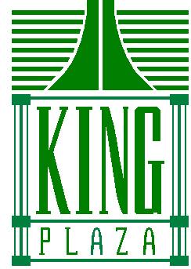

Fitness Room Release Form

I, the undersigned for and in consideration given to me by Metropolitan Toronto Condominium Corporation No. 954 to use the fitness room at 92 King Street East do hereby for myself and heir, executors, administrators and assigns, forever, release, discharge, fully indemnity and save harmless M.T.C.C. 954 and its affiliated, their respective directors, officers, employees, agents successors and assign from any claims, losses, damages, injuries, or demands whatsoever arising for damage to property, personal injury or death, at any time and in any manner arising, in whole or in part, directly or indirectly, from or in consequences of the use of the facilities, rooms, equipment or any other activities in any related thereto and thereof, whether or not such damage, personal injury, or death is due to the negligence of any person whomsoever, including M.T.C.C. 954 and its affiliates (directors, employees, agents, successor, and assigns).

________________ ______________
Print Name Unit #

________________ ______________
Signature Date

_______________
Building Fob #

